PLANNING TAB

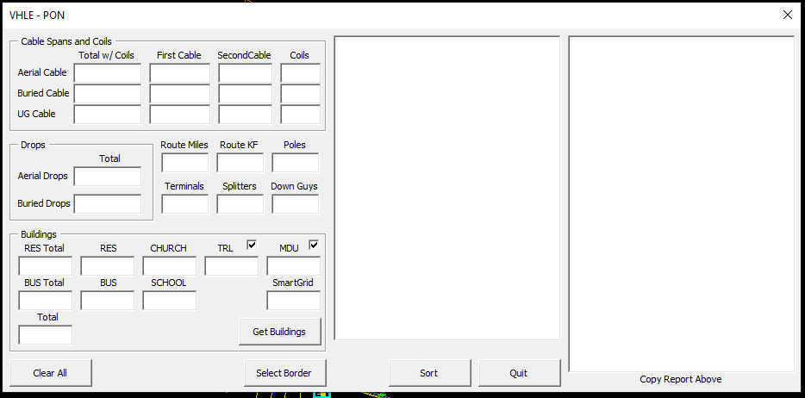

VHLE-PON: Gets cable environments, cable lengths, customer totals, and approximate units. It does this by getting all the customer, cable_span, coil, splice, anchor, and guy blocks from within the closed polyline (polygon) you select. If you hit sort after getting the numbers, it will add the units to a text field so you can copy and paste the data into Excel.

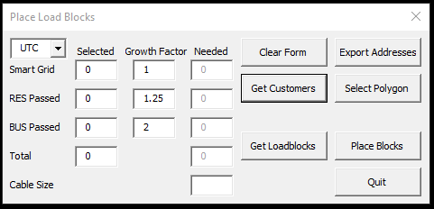

LOAD BLOCKS: Get the customers in your selection and tells how many fibers will be needed. To select customers manually click on Get Customers. To select all customers within a polygon click on Select Polygon. To get the data from an existing Load Block, click on Get Loadblocks. To place a new Load Block, clisk on Place Blocks. Seems like we needed a spreadsheet of the addresses within a polygon for some reason. Export Addresses still creates the spreadsheet.

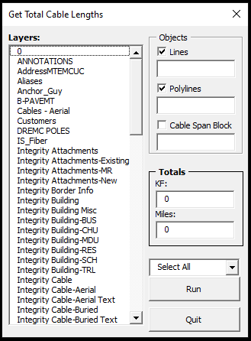

GET CBL LENGTHS: Gives you the total length of cable within the selected layer. If you click on the text “Layers:” it will let you manually select an object and select its layer.